Day 6 Beginner Python Functions

<https://www.udemy.com/course/100-days-of-code/learn/lecture/18126733#overview>

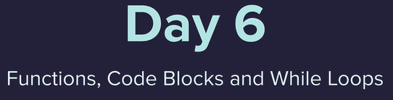

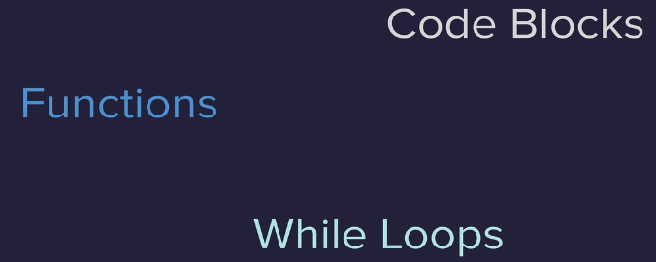

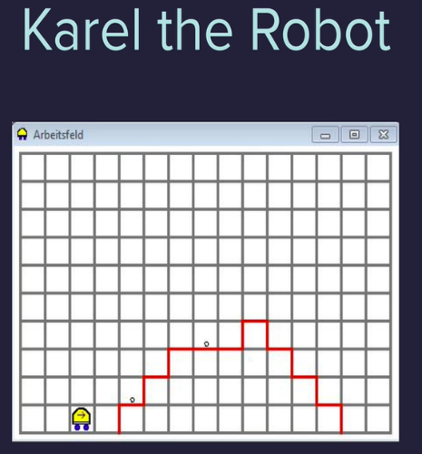

Final Project

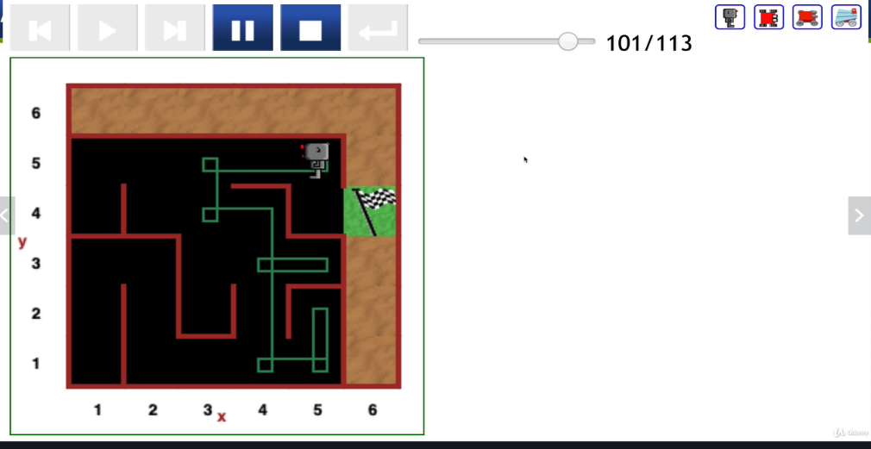

**Python Functions**

<https://docs.python.org/3/library/functions.html>

Built in Python functions 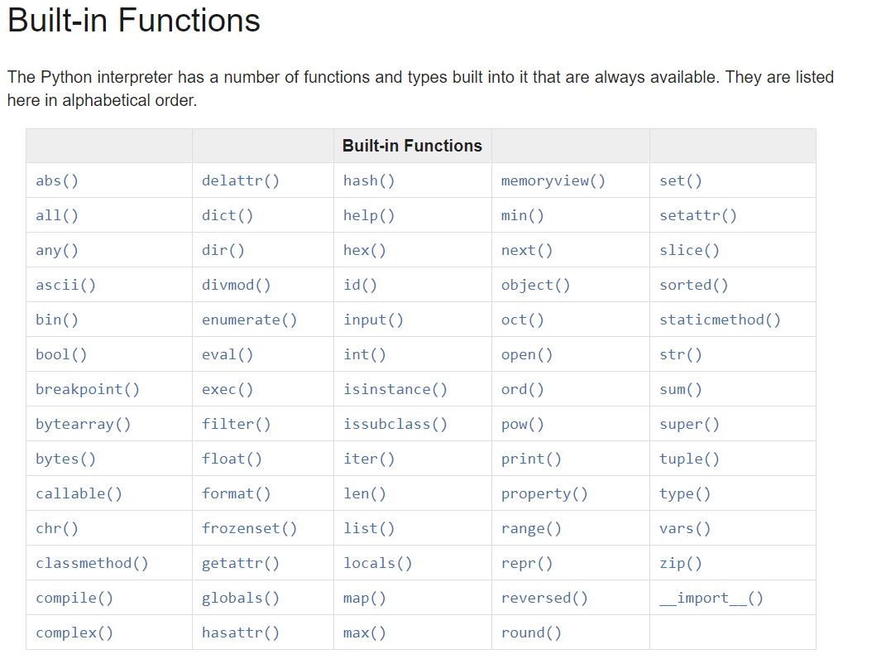

Print() function

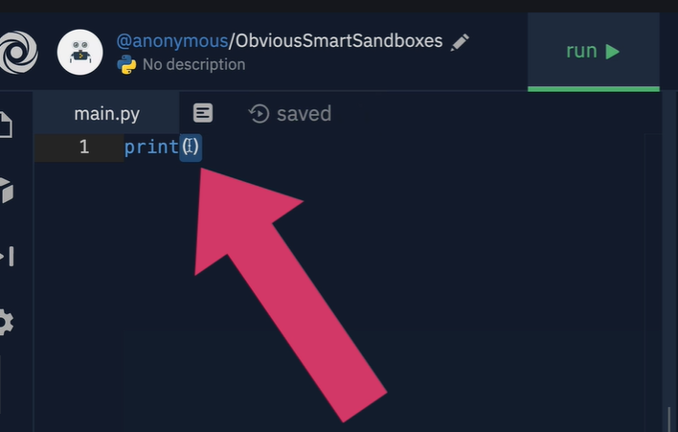

We can make our own functions

Start off with for definition

Then name()

Followed by :

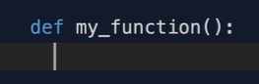

Below this indented the stuff the function should be doing

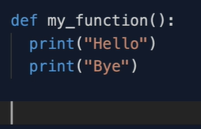

Then call the function

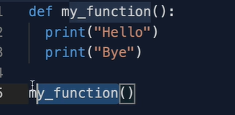

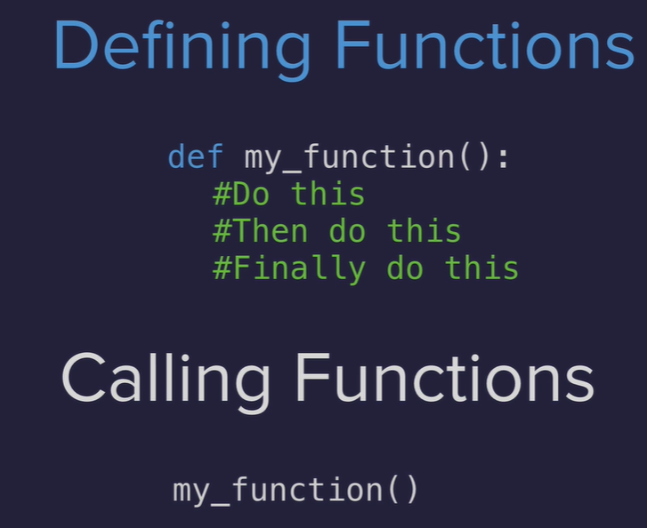

<https://reeborg.ca/reeborg.html?lang=en&mode=python&menu=worlds%2Fmenus%2Freeborg_intro_en.json&name=Hurdle%201&url=worlds%2Ftutorial_en%2Fhurdle1.json>

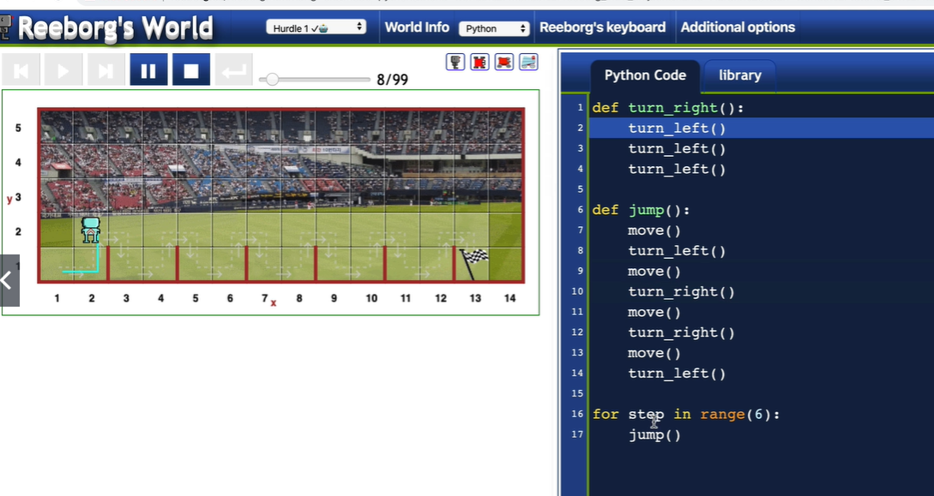

Using for in range to jump six times

Indentation 4 spaces

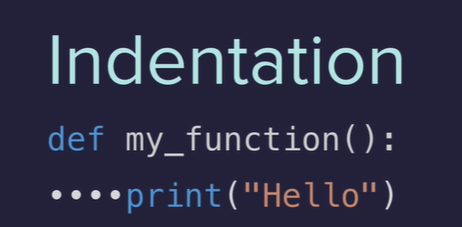

Not indented

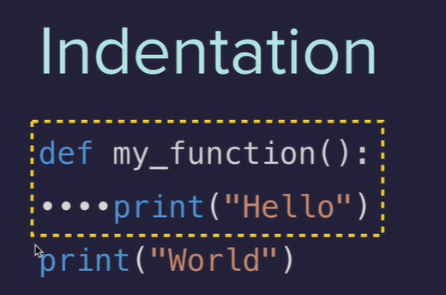

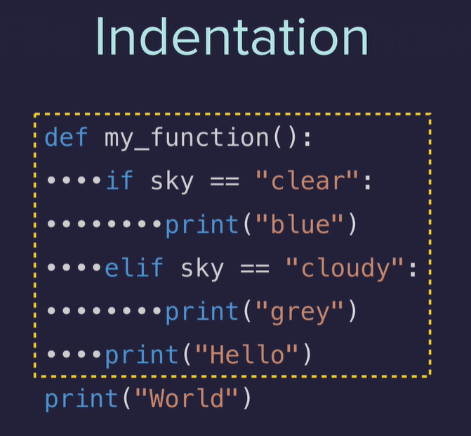

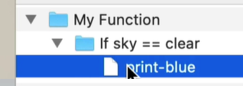**==**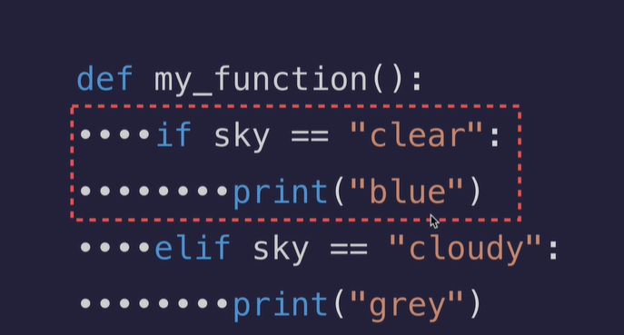

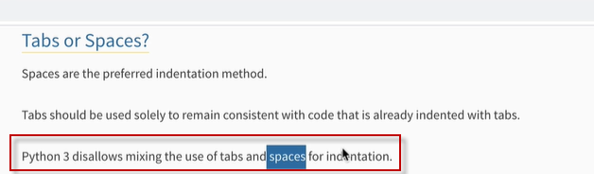

Code editors can allow changing the tab key to = 4 spaces

**While loops – will continue while a condition is true**

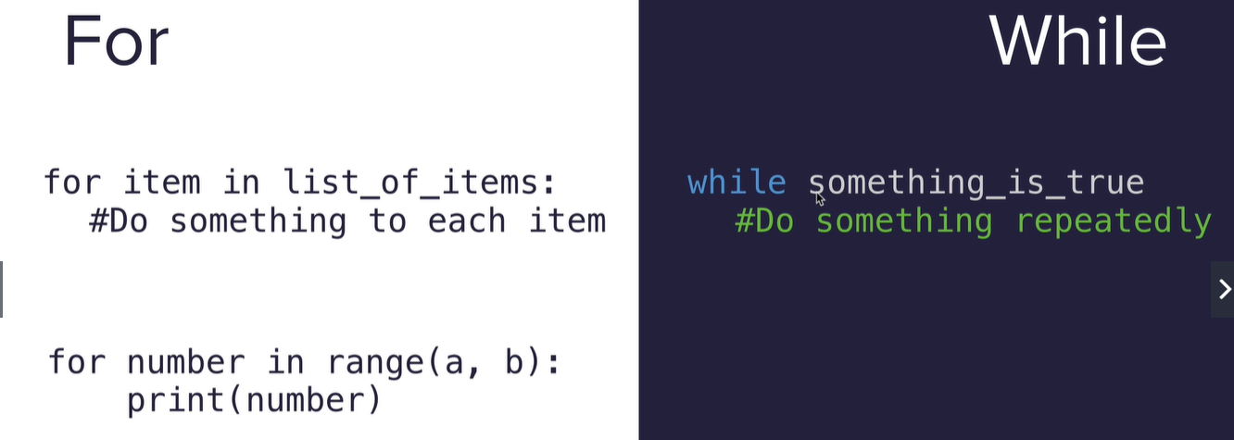

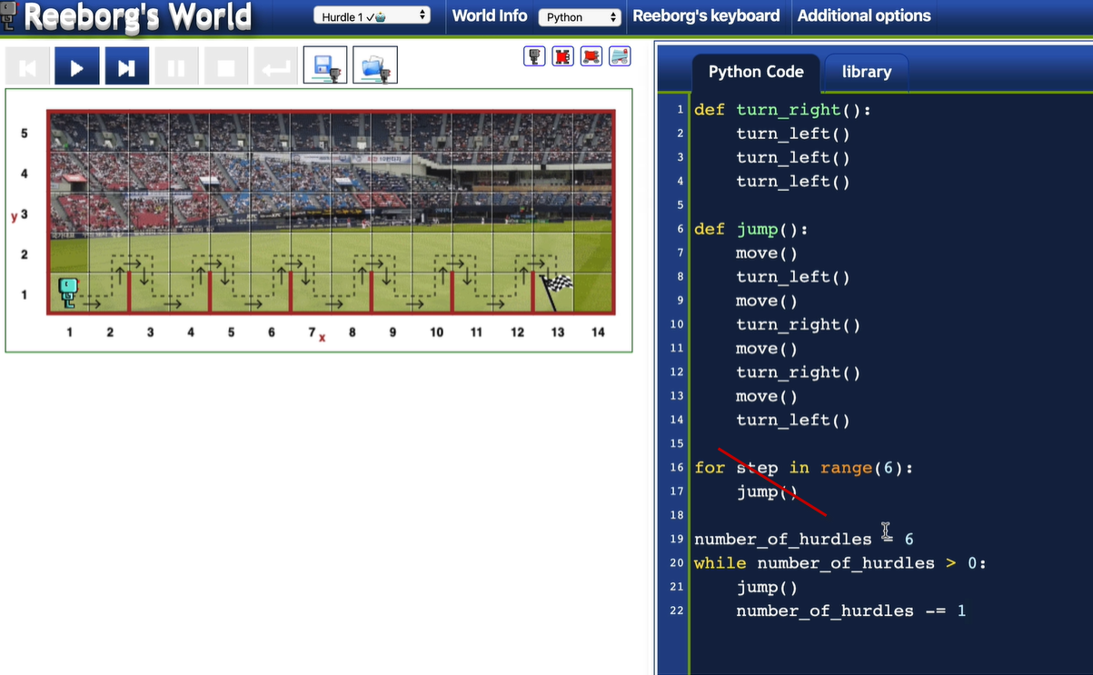

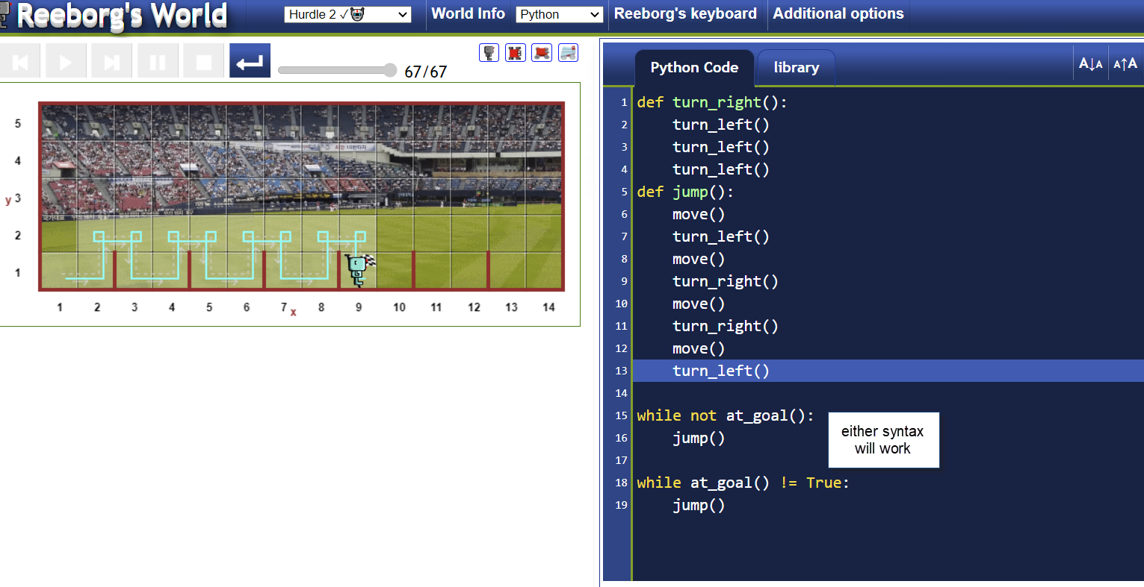

**For loops** are good when you are iterating over something and you need to do d0 soemting with each thing you are iterating over.

Like …

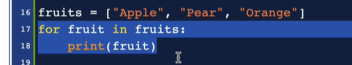.

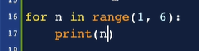

**While loops** are good when you don’t care what number in a sequence you are in or item in a list you are in, you just need to repeat a function over and over until you reach a condition that you set

Like ….

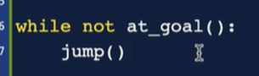 Also while loops can be dangerous because they can become infinite loops that crash the computer

Using while loop to jump over hurdles of random heights 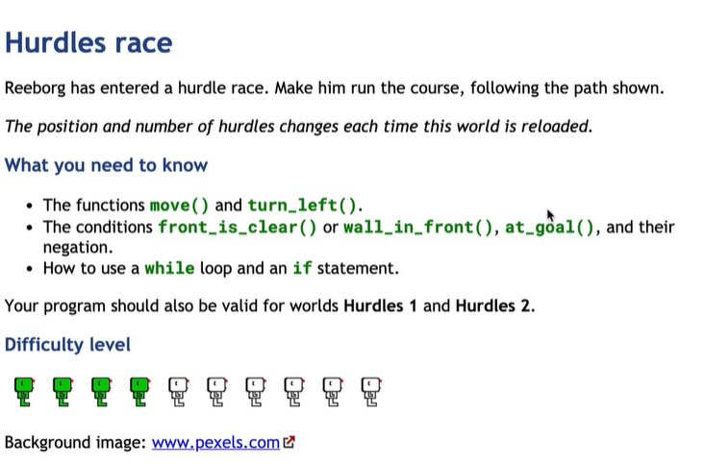

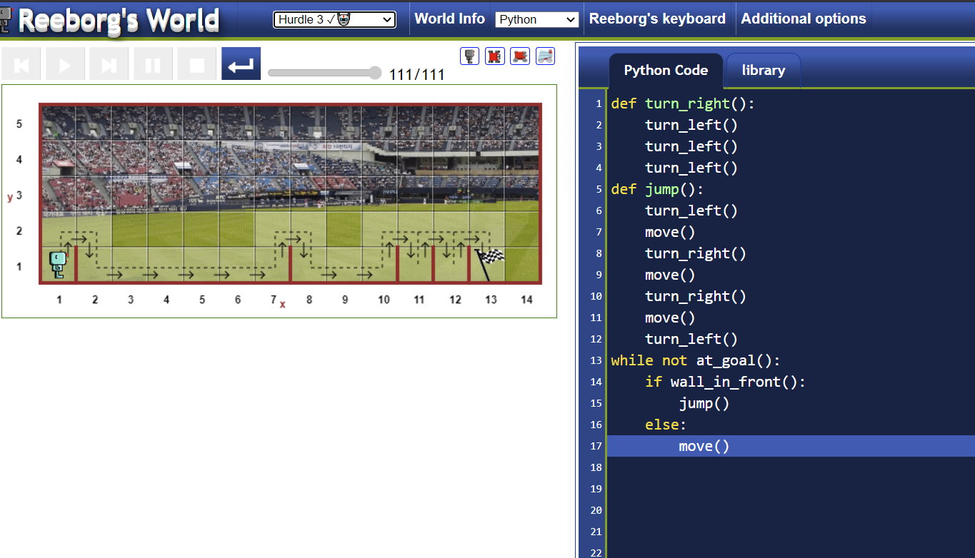

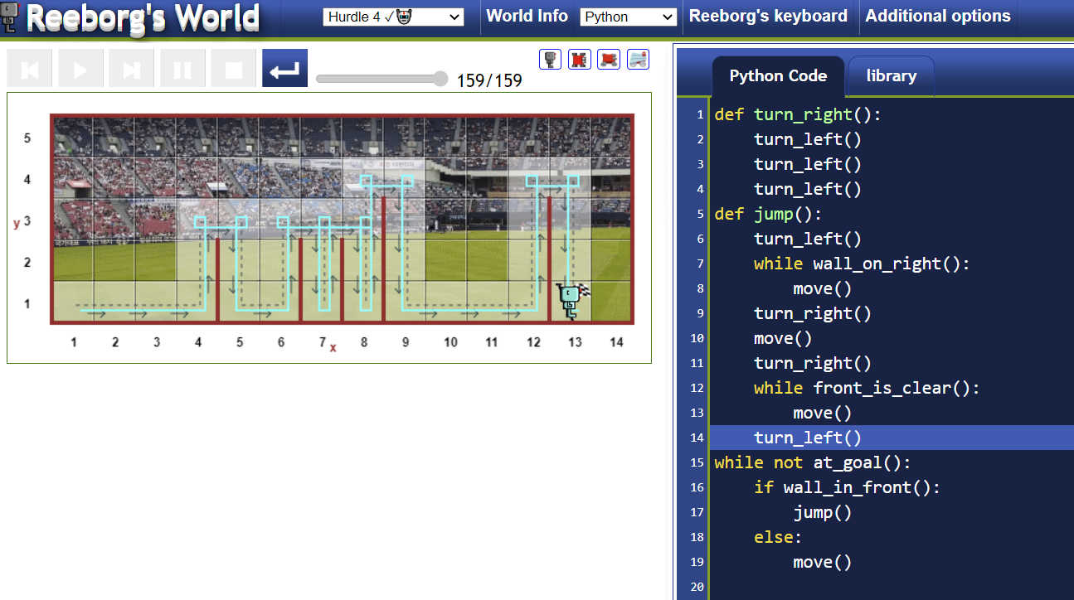

Maze problem

